**How to use the Jupyter Notebook?**

**Description: Frequently used functions in the interface and official web links.**

**Time:10mins.**

When you open the notebook, you can start by clicking on the buttons (don’t click Logout).

Here only shows the frequently used buttons, and you can get more information through the Jupyter Notebook official website.

* **Name**

Let’s start from the notebook Interface:

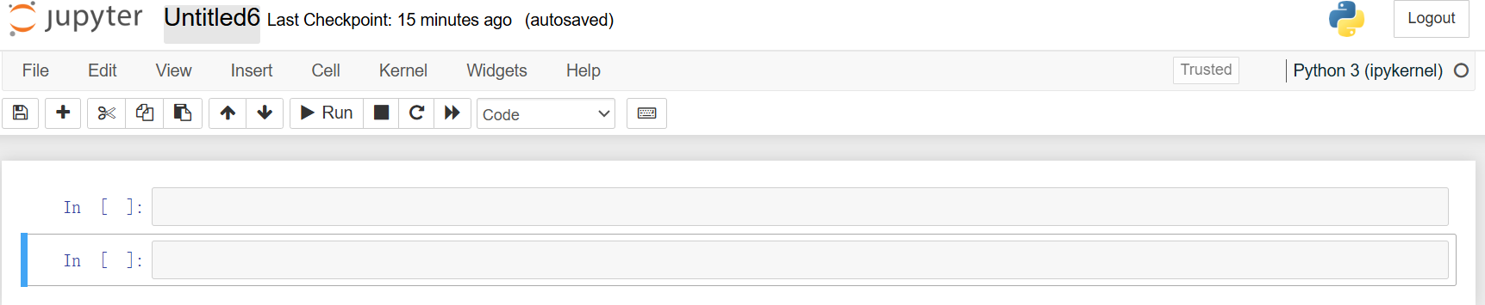

If you click on the name(‘Untitled6’), you can change the name of your notebook.

We can change it to ‘CHANGENAMES ’.:



* **Code or Markdown**

The pictures below show the differences between a Markdown and a Code cell.

You can see the different usages of ‘#’ in the two cells:

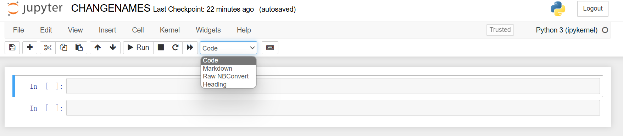 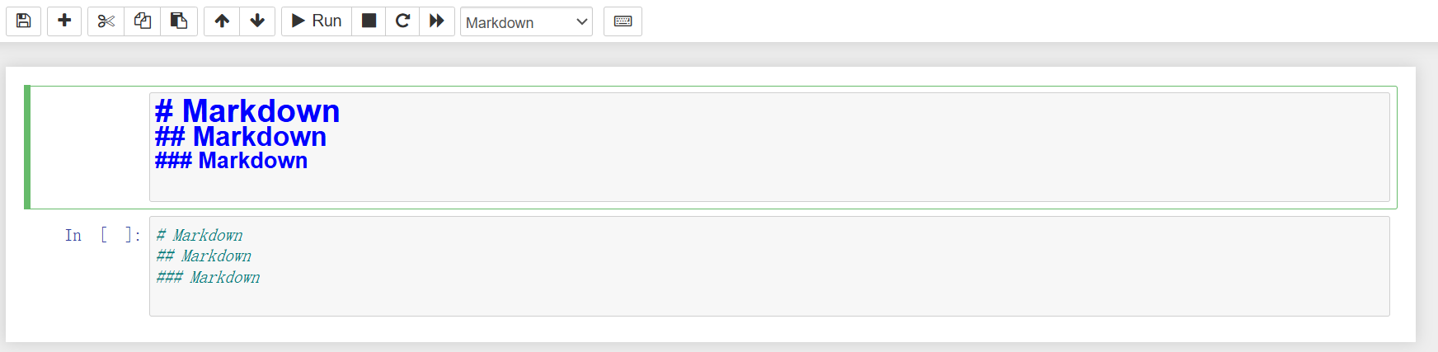

We usually use the ‘#’ symbol in the Markdown cell to change the font size.

* **Others**

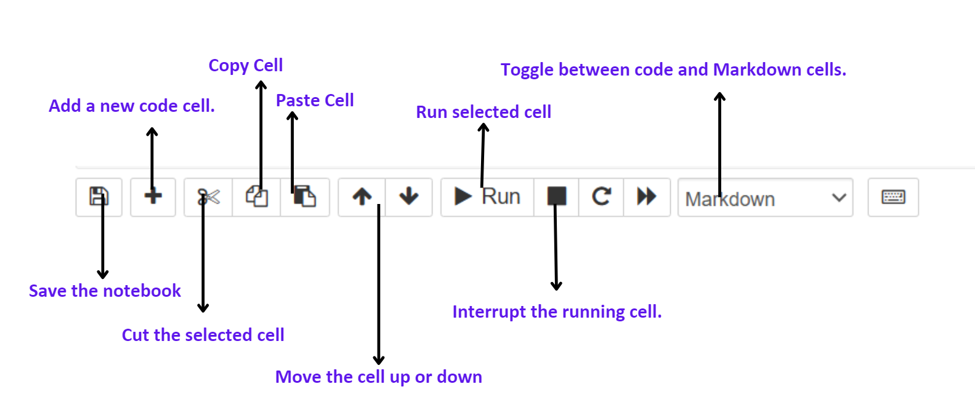

* **TIPs:** **Save** your notebook when you complete parts of your project; if you accidentally delete something, press **Ctrl+Z** to withdraw, and conversely, press **Ctrl+Y** .
* **For more information**, please refer to the official Jupyter Notebook website:
* <https://jupyter-notebook.readthedocs.io/en/stable/>

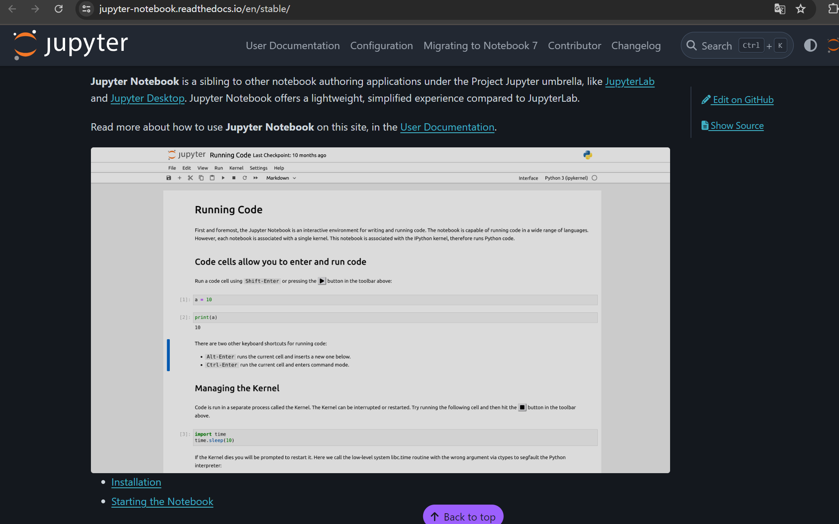

* <https://jupyter-notebook.readthedocs.io/en/stable/notebook.html>

